**INNER JOINS**

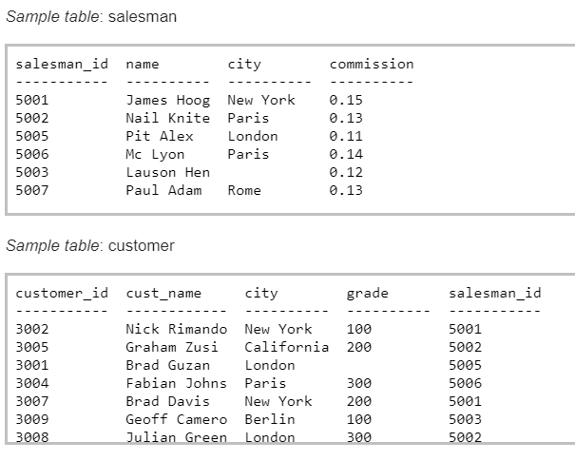

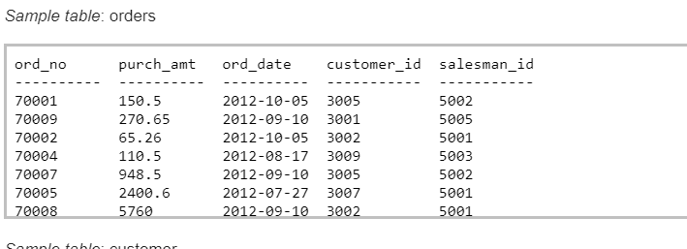

1. Write a SQL statement to prepare a list with salesman name, customer name and their cities for the salesmen and customer who belongs to the same city.
2. Write a SQL statement to make a list with order no, purchase amount, customer name and their cities for those orders which order amount between 500 and 2000.
3. Write a SQL statement to know which salesman who are working for some customer.
4. Write a SQL statement to find the list of customers who appointed a salesman for their jobs who gets a commission from the company is more than 12%.
5. Write a SQL statement to find the details of an order i.e. order number, order date, amount of order, which customer gives the order and which salesman works for that customer and how much commission he gets for an order.
6. Show name of all salesman along with their customers’ name.
7. Write a SQL statement to make a list in ascending order for the customer who holds a grade less than 300 and works either through a salesman or by own